Design 4

Group:

Houda Alberts, 10740287

Jasper Bakker, 10260250

Milou Bisseling, 10427538

David Lips, 6225950

# Problem 1: Rainbow color map

In 2011, the NASA released the highest resolution near-global topographic map of the moon ever created (back then). The topographic map shows the surface shape and features over nearly the entire moon with a pixel scale close to 100 meters. Every pixel is about the size of two football fields placed side-by-side. The visualisation is made for lunar scientists who want to do research on several properties of the moon. They can now determine how the crust of the moon has deformed, better understand impact crater mechanics, investigate the nature of volcanic features, and better plan future robotic and human missions to the moon.

The creators of this visualisation chose to paint the originally grayscale pixels with rainbow colors that represent the altitude. The legend has an adapted rainbow scale starting at the color violet, as the lowest elevation, and ending in the color white, as the highest elevation. Originally the rainbow scale does not include white, it only includes the colors red, orange, yellow, green, blue, indigo and violet. Using rainbow color scales for representing continuous brings up a lot of perceptual issues. The first issue is that people are very bad in ordering colors on a rainbow color scale. People do not have the natural instinct to make greater-than and less-than relationships between the rainbow colors, they need to remember the order or they need to consult a legend. The second problem is the problem that detail is harder to see in a rainbow color map than in a gray-scale image because we can not see the contrast so well. The third problem is that the divisions between hues create edges in the visualization. These edges are entirely perceptual and have no relation to the data, so people see boundaries that do not actually exist. Another problem lies within the fact that people can be colorblind. By using this scale, people who are colorblind, cannot read the data (well). So the visualization fails to successfully convey information. They tried to convey an absolute sense of height with the rainbow color scale but it would have been easier to convey this absolute sense of height with a grayscale map. So, we do not see a grounded, specific reason for this rainbow color map to work.

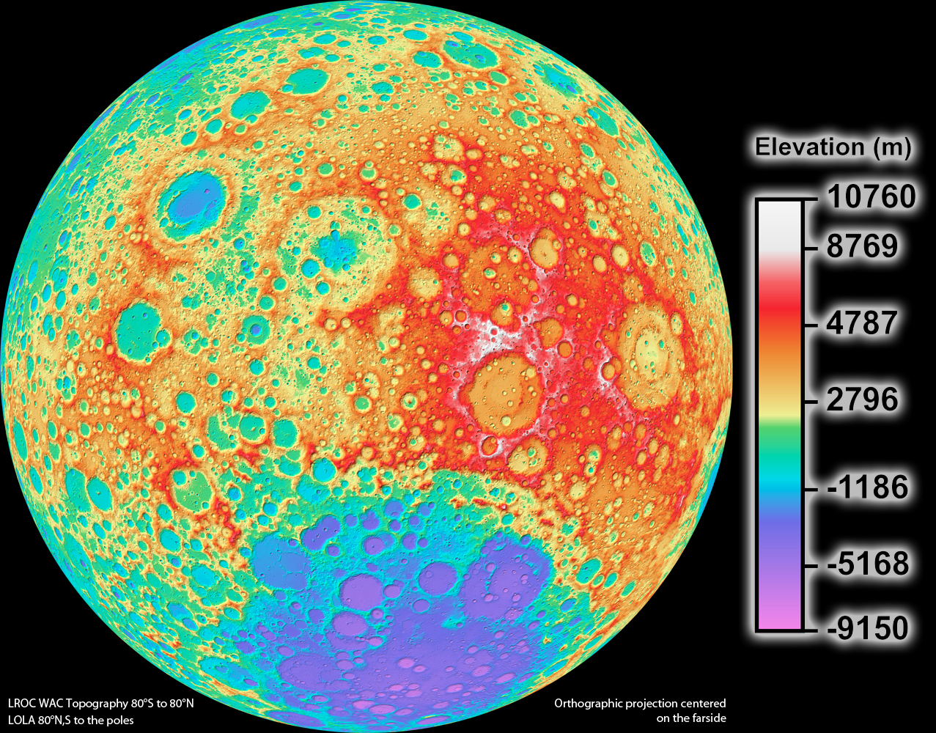

<https://www.nasa.gov/mission_pages/LRO/news/lro-topo.html>

# Problem 2: Patterns and colors in maps

Patterns and colors are essential to maps. Compare a search for Harvard University on two interactive maps (e.g., Google Maps, Bing Maps, Yahoo! Maps, Apple Maps, map.harvard.edu). Answer the following questions, making references to concepts explained in Ware such as pattern recognition and properties of color. Please include screenshots of the examples you are comparing.

* Which map promotes an easier visual search for buildings?

The Harvard map on map.harvard.edu makes it easiest to visually search for buildings for two main reasons:

1) As mentioned in Ware, when it comes to visual search considerations, visual distinctness, or contrast, is one of the most important aspects. In fact, Ware mentions that “*The most important single principle in the use of color is that whenever detailed information is to be shown, luminance contrast is necessary.*” In this sense, the Harvard map is much more effective than the Google Maps, as the buildings have a much stronger contrast with the background through the utilization of both a dark (the dark green of the terrain) and a light color (the color of the buildings). Google Maps, in contrast (pun intended), use light colors for both the terrain and the buildings, which, although still distinguishable, does not show a strong difference compared to the Harvard Map.

2) The Harvard map shows the names of each building as a label, whereas the Google Maps does not with the exception of several buildings that show a name when you zoom in very closely. Obviously, the search for a specific building is much easier when you have the corresponding label in view from the start.

* Which map more effectively visualizes routes from a random point A to point B?

Through its interactivity, Google Maps can be used more efficiently since it allows you to select any two points, A and B, after which it will compute the most efficient walking route between the two points, including instructions. The Harvard Map is not able to do so and requires manual inspection of the roads between point A and B. Another thing about the Harvard map is that it does not allow you to highlight a specific route.

* Which map is an overall better visualization, and why?

For the sole purpose of finding your way around the Harvard Campus (which, based on experience, is a non-complex location with a relatively small amount of buildings), the Harvard Campus Map is the winner. It’s effective use of visual contrast and labelling to highlight buildings makes it easier to find a specific place than Google Maps, which has no labelling for most buildings (unless you zoom in extremely closely) and therefore makes it very difficult to find a specific location. That said, we’d have liked to see more interactivity from the Harvard Map, such as the ability to select specific buildings from a side menu, and to see those highlighted in a distinct color to facilitate the visual search even more.

Google maps:

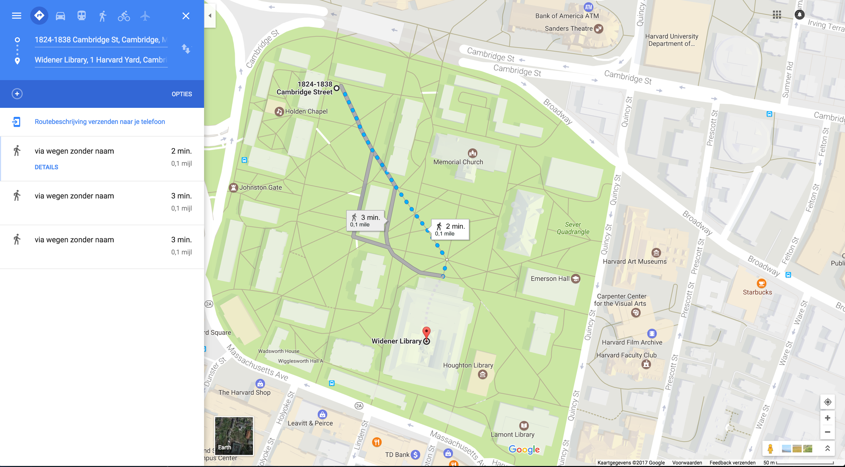

Harvard maps:

